DataBase Assignment: Sample Database

Northwind Database

Student: Chindea Miruna

Professor: Cenan Călin

Group: 30424

**1. Source**

https://www.microsoft.com/en-us/download/confirmation.aspx?id=23654&fbclid=IwAR3Cfpmgon5qRKLASvcqyFe3W-ZRRIMVQMHoGueKxgopFLk-KcDtS2hFEp4

**2. Database description**

Northwind database is a database about a company named Northwind Traders. In this database, there is stored information about the sales transaction that occurs between the company and its customers and the purchase transactions between the company and its suppliers. The information about the database refers to the products they are supplied with and which they sell, the suppliers, the customers, the orders and all the details about those orders. Moreover, we have information about their employees and their working territories and regions.

**3. Database Diagram**

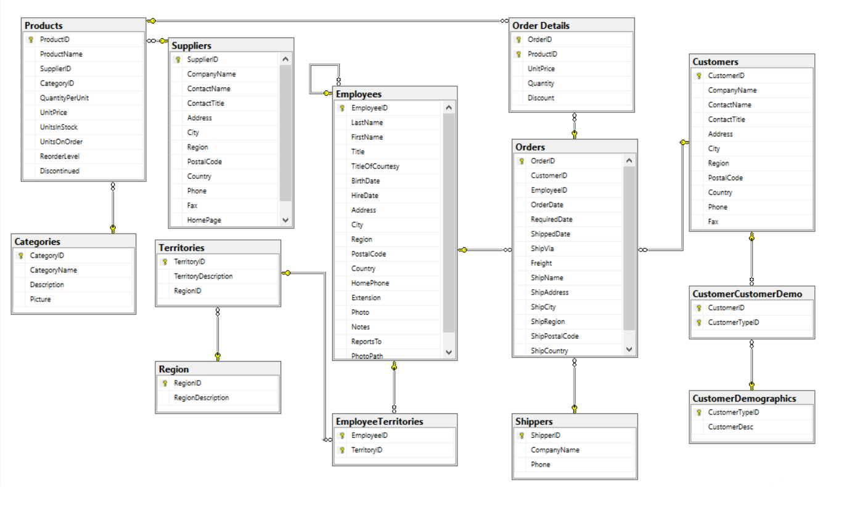

**4. Tables**

**Suppliers:** companies which supply the products to the Northwind company and details such as the contact name, address, city, region, postal code, country and phone number.

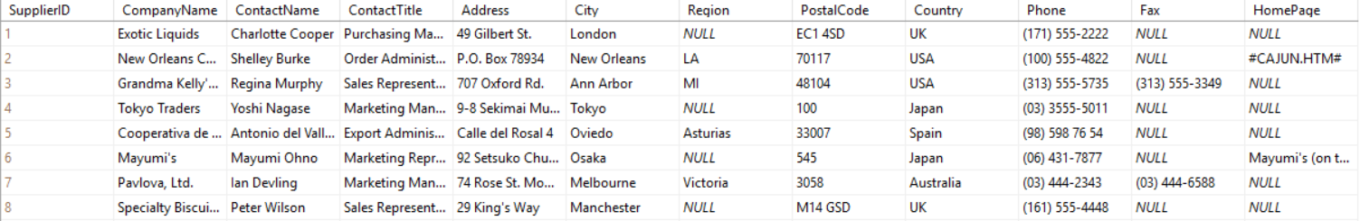

**Customers:** companies which buy from the Northwind company and details such as contact name, city, region, posta code, country, phone number.

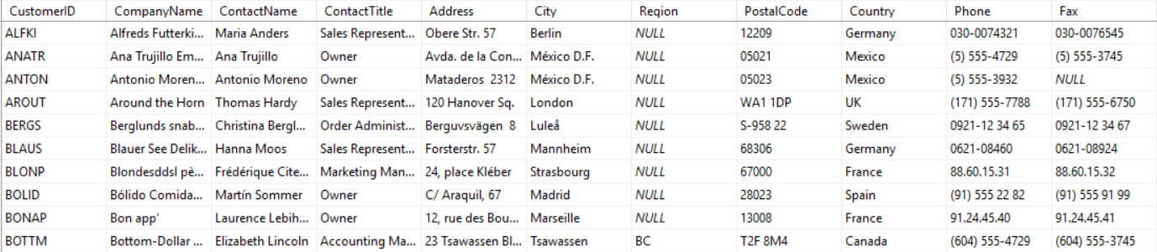

**Employee:** people who work for the company and details such as their name, date of birth, date of hiring and their addresses.

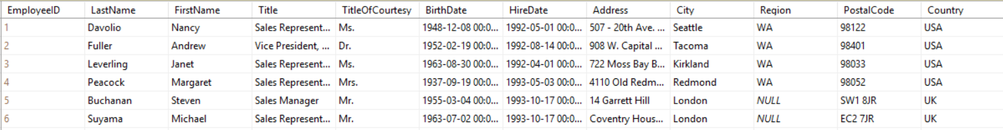

**Categories:** the categories of products of the company with a description and a picture.

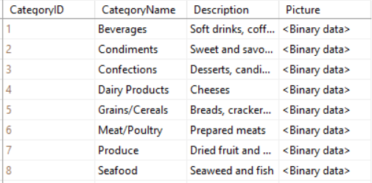

**Regions:** regions in the country where the employees are working.

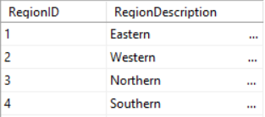

**Territories:** the territories which belong to every region.

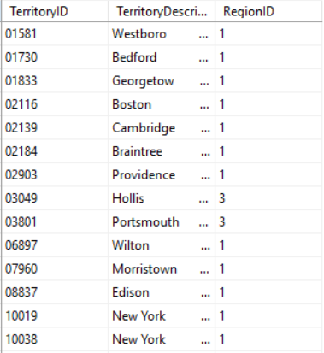

**EmployeeTerritories:** the employees of the company and their working territories

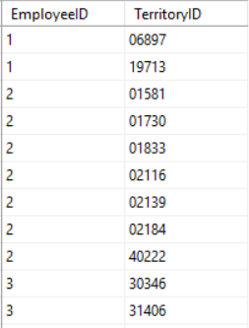

**Orders:** all the orders from the customers of the Northwind company, such as the id of the customer which made the order, the date of the order, the id of the shipping company, and the addresses of the orders.

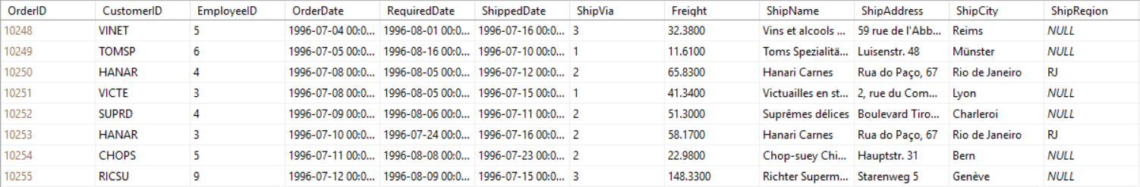

**Order Details:** more details for the above orders, such as price per unit, quantity and the discount.

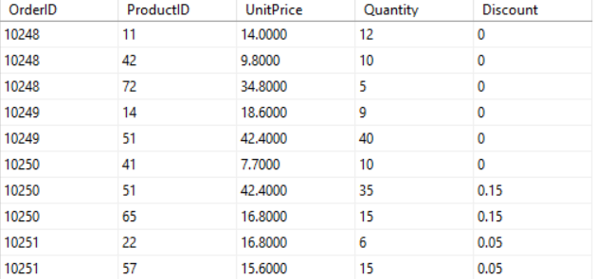

**Shippers:** the companies that ship the products from Northwind to their customers.

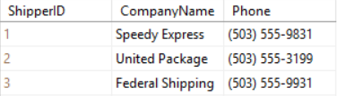

**Products:** all the products of the company and their details, such as the name of the product, the id of the supplier, the quantity per unit, the price per unit, the units in stock etc.

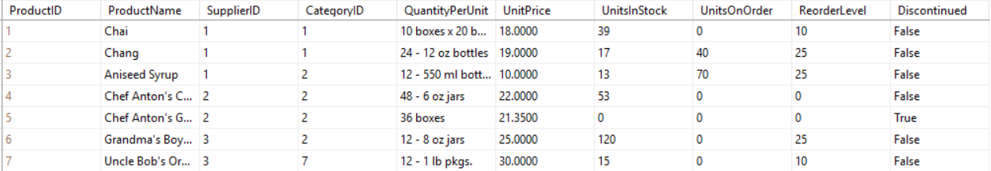

**5. Primary keys**

- EmployeeID: primary key used to uniquely identify each employee of the Northwind company

- OrderID: primary key used to uniquely identify each order of the Northwind company

- ShipperID: primary key used to uniquely identify each shipping company

- TerritoryID: primary key used to uniquely identify each territory in which the Northwind company activates

- CategoryID: primary key used to uniquely identify each category of products of the company

**6. Foreign keys**

- CustomerID: foreign key in the table Orders, pointing to the table Customers; used to identify the customer that made the order

- ShipVia: foreign key in the table Orders, pointing to the table Shippers; used to identify the company which shipps the products

- ReportsTo: foreign key in the table Employees, pointing also to the table employees; used to identiy the employee to which every employee reports

- CategoryID: foreign key in the table Products, pointing to the table Category; used to identify the category which each product belongs to

**8. Relationships:**

We have **one-to-many** relationships:

- Between the tables Categories and Products: **CategoryID** (primary key) from Categories and **CategoryID** (foreign key) from Products; there can be more products of a category but a product cannot belong to multiple categories

- Between the tables Orders and Customers: CustomerID(primary key) from Customers and CustomerID (foreign key) from Orders; there can be more orders made by a customer but there cannot be an order made by multiple customers

- Between the table Employees and itself: **EmployeeID** (primary key) and **ReportsTo** (foreign key); an employee reports to a single other employee, but an employee can get reports from multiple employees

We have **many-to-many** relationships:

- Between the tables Employees and EmployeeTerritories: EmployeeID is the primary key for both of the tables; an employee can work in multiple territories, and in every territory can work multiple employees

**9. Views**

1. I made a view to show me the orders from September 1996, ordered by the name of the category.

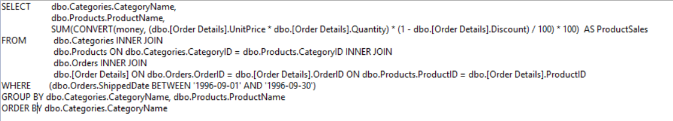

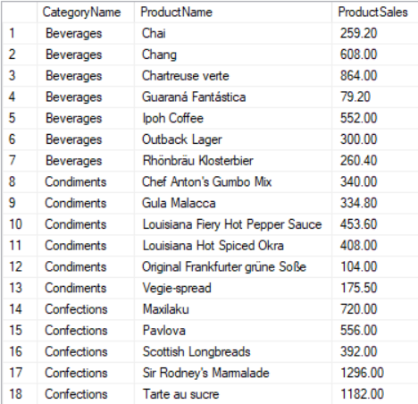

2. A view to show me all the order subtotals.

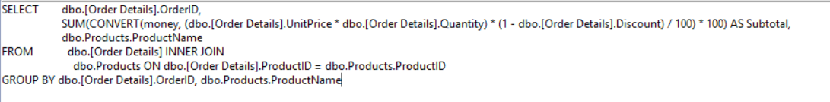

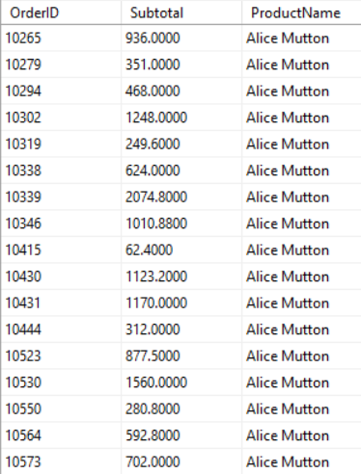

3. A view to show me the quantity of each product that hasn’t been discontinued.

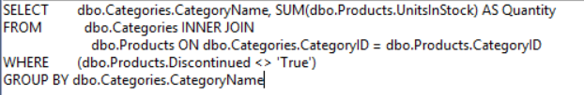

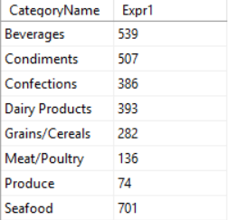

4. A view to show me all the discontinued products:

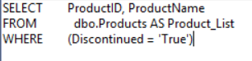

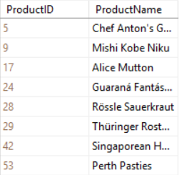

**10. Constraints:**

I would propose a lot of constrains about some attributes to allow only digits and expressions (not allow letters in phone numbers) , some examples being from the table Customers (Phone, Fax) and the same attributes from other tables, and from the table Employees( HomePhone).

Also, the HireDate from the Employees table should be a valid date (not before the company Northwind was founded e.g. not ‘1682-01-01’ ).

**11. Migration**

I migrated my database from SQL Server to MySQL Workbench:

